**Optimizing User, Group, and Role Management with Access**

**Control and Workflows**

**Team ID: NM2025TMID15839**

**Team Size: 4**

**Team Leader: Reena V**

**Team Member 1: Ronica S**

**Team Member 2: Balamurugan Sah A S D**

**Team Member 3: Rahul V**

**Problem Statement:**

Within a small project management setup involving a Project Manager (Alice) and a Team Member (Bob), the absence of well-defined roles, structured workflows, and proper access restrictions creates confusion. This lack of clarity often leads to task mismanagement, accountability gaps, and difficulty in tracking project progress.

**Objectives:**

**1.Clearly Define User Roles** – Assign specific roles to Alice (Project Manager) and Bob (Team Member) to make responsibilities and access privileges within the project management system more transparent.

**2.Apply Access Control Measures –** Build a system that limits Bob’s permissions, preventing him from creating or modifying projects, while still enabling him to view and update only the tasks assigned to him, thus avoiding unauthorized changes.

**3.Organize Workflow Processes** – Create a well-structured workflow for task distribution and progress monitoring, allowing Alice to easily delegate tasks to Bob and track their completion effectively.

**Skills:**

User Management, Groups, Roles, Tables, Access Control Lists, and Flow Designer.

**TASK INITIATION**

**Milestone 1: Users Activity: Create Users**

1. Open ServiceNow.
2. Navigate to 'All' > search for Users.
3. Select 'Users' under System Security.
4. Click 'New' and provide user details.
5. Save the new record.
6. Repeat the process to create a second user.

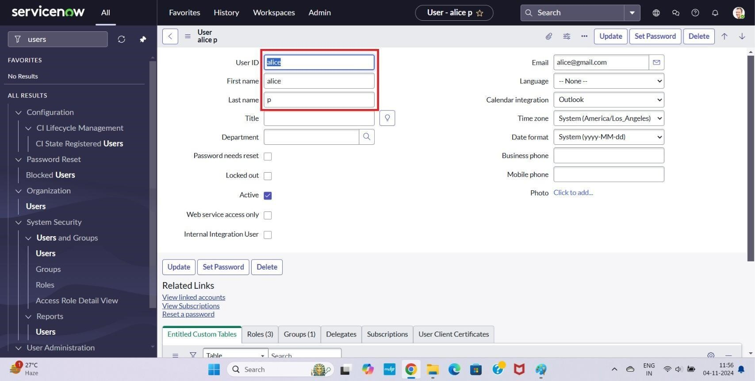

# Figure 1

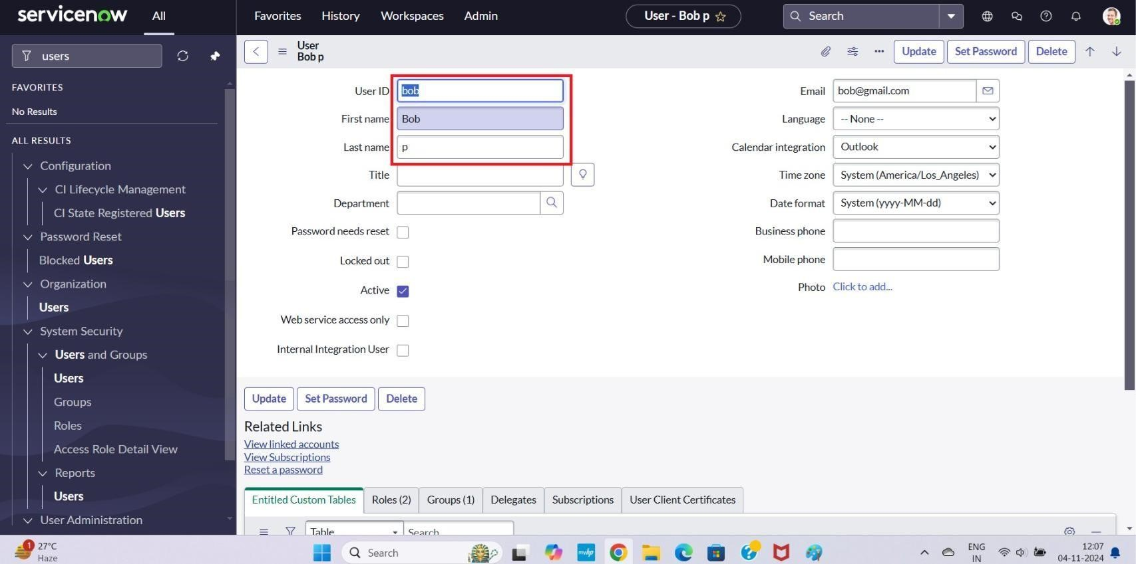

# Figure 2

**Milestone 2: Groups**

**Activity 1: Create Groups**

1. In ServiceNow, go to 'All' > search for Groups.
2. Select 'Groups' under System Security.
3. Click 'New', enter group details, and save.

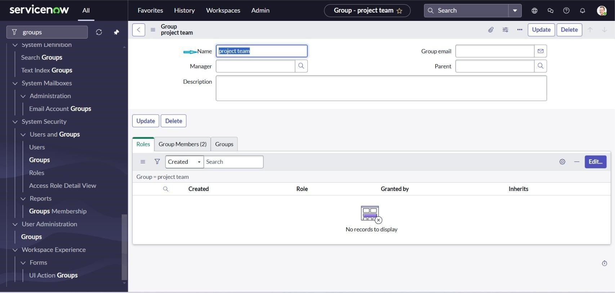

**Figure 3**

**Milestone 3: Roles**

**Activity 1: Create roles**

1. In ServiceNow, search for Roles under System Security.
2. Select 'New', enter details for the role, and save.
3. Create an additional role using the same steps.

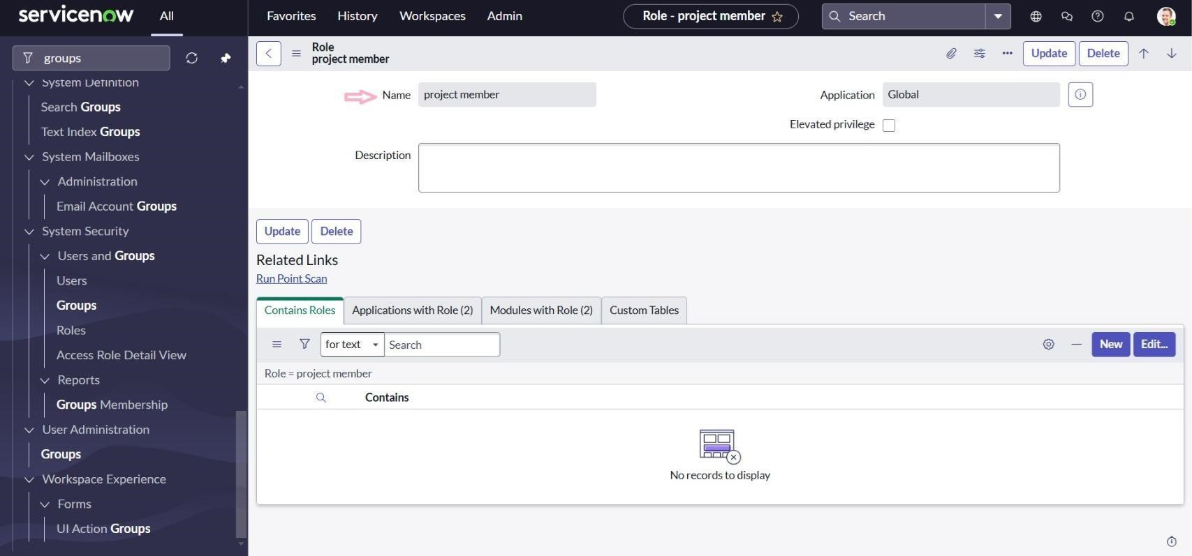

# Figure 4

**Milestone 4: Table**

**Activity 1: Create Table**

1. In ServiceNow, navigate to 'All' > search for Tables.
2. Create a new table labeled 'Project Table', enabling module and mobile module options.
3. Define necessary columns and save.
4. Repeat the process to create 'Task Table 2'.

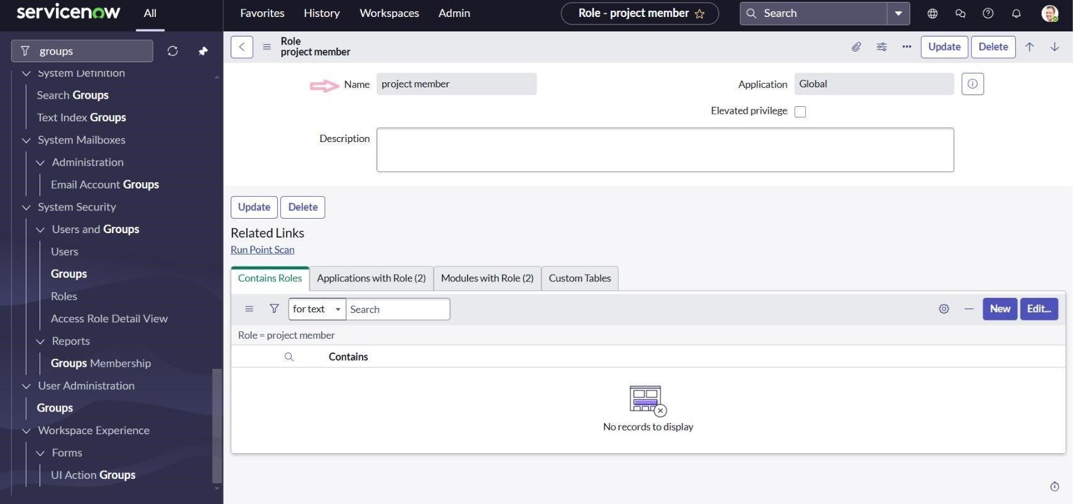

# Figure 5

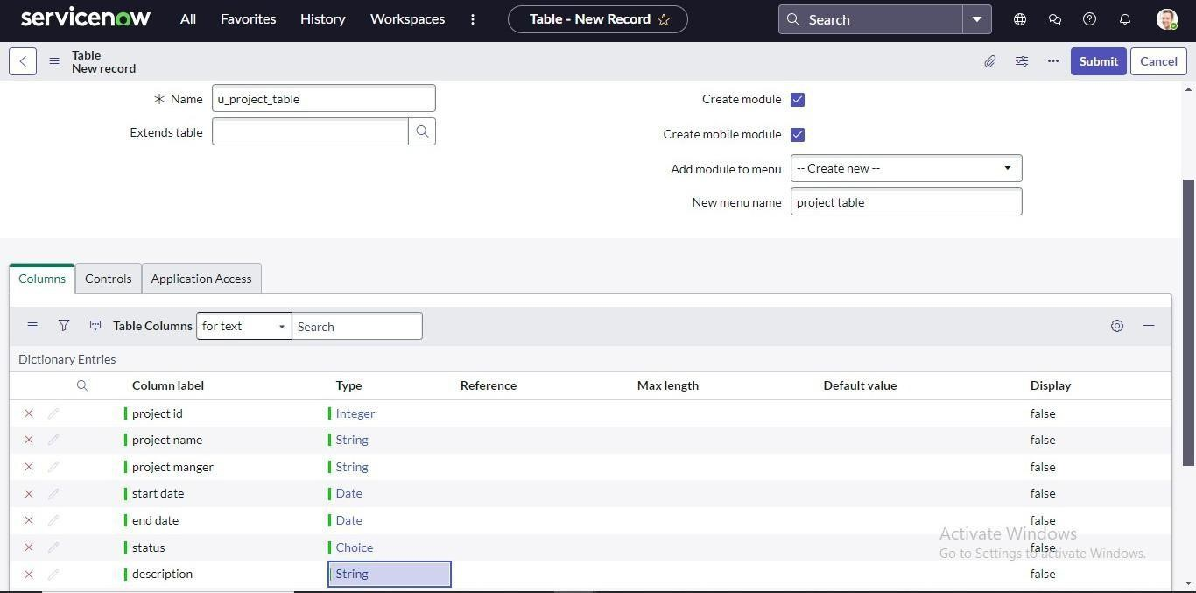

# Figure 6

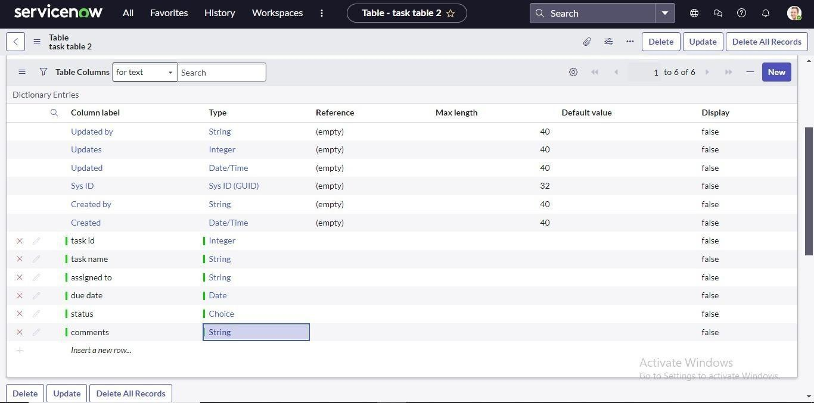

**Figure 7**

**Milestone 5: Assign user to groups**

**Activity users to project team group**

1. Open ServiceNow and search for Groups.
2. Select the 'Project Team' group.
3. Under Group Members, edit and add Alice P. and Bob P., then save.

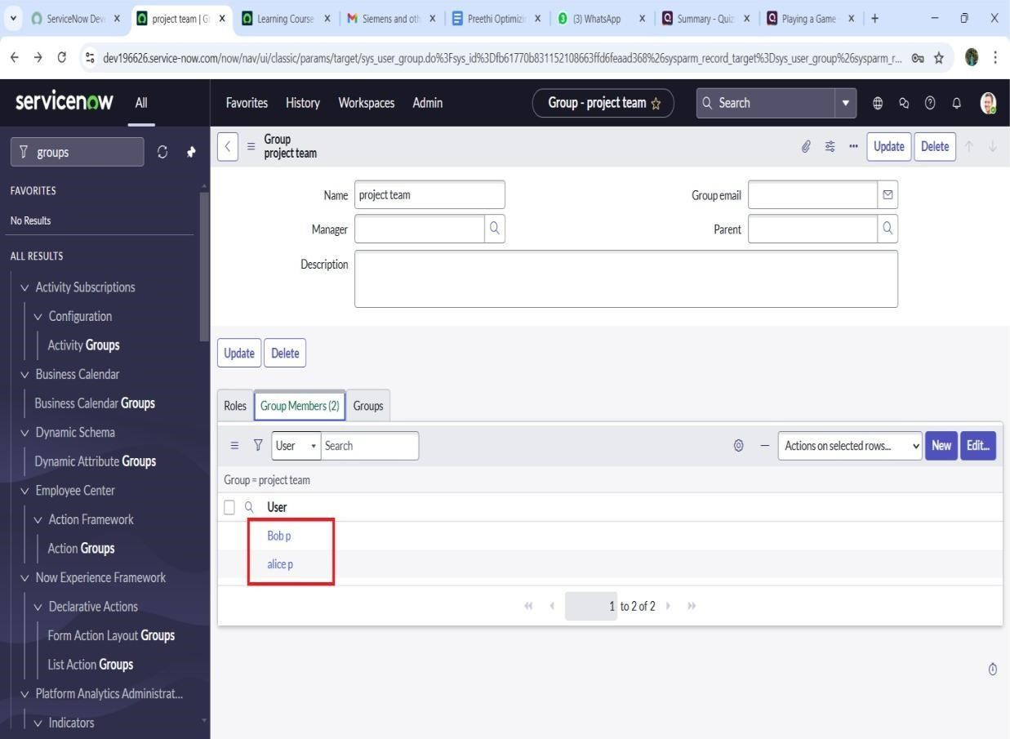

# Figure 8

**Milestone 6: Assign role of users**

**Activity 1: Assign roles to alice user**

1. Open ServiceNow and go to All → Users.
2. From the options, select Tables under System Definition.
3. Choose the Project Manager user account.
4. In the Project Manager’s profile, click Edit.
5. Add the Project Member role and save.
6. Again, click Edit and assign the u_project_table role and the u_task_table role.
7. Save the changes and update the form.

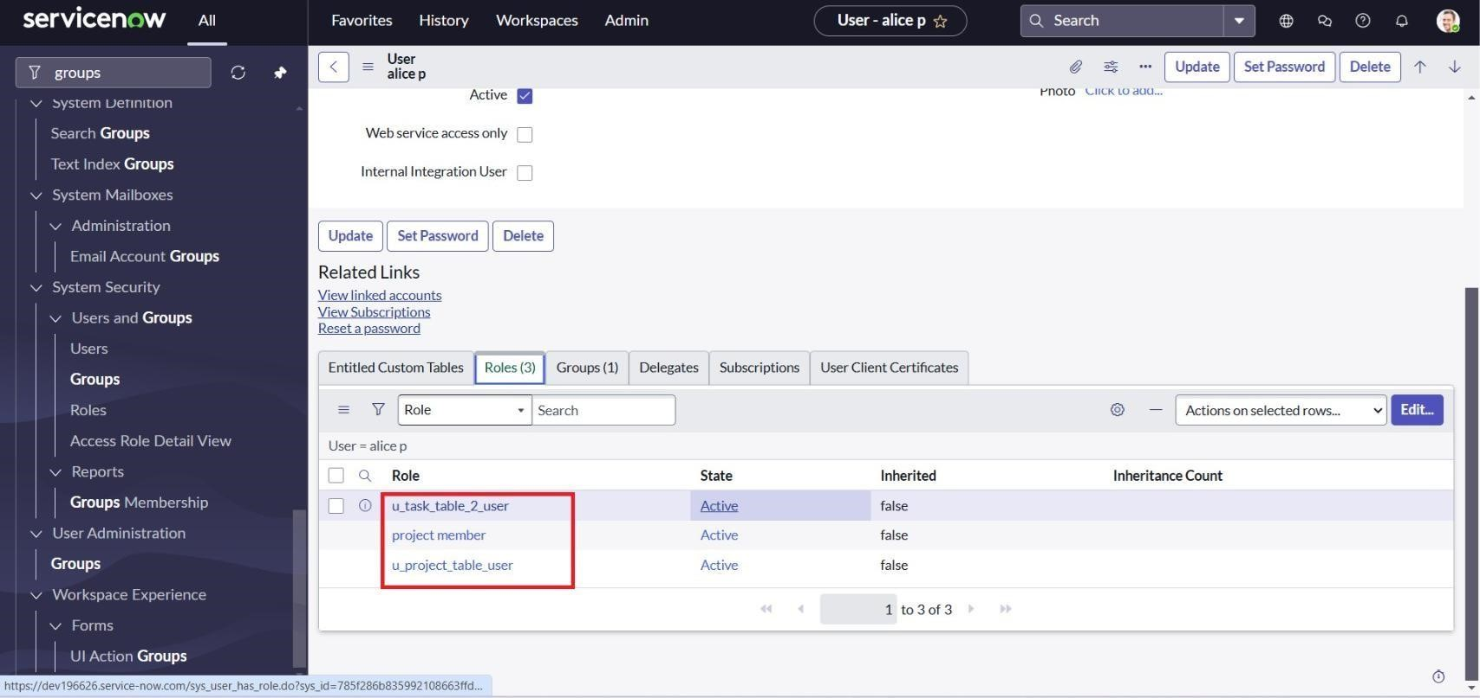

# Figure 9

**Actitvity 2: Assign role to bob user**

1. Open ServiceNow and navigate to All → Users.
2. Select Tables under System Definition.
3. Choose the user account for Bob P.
4. In the Team Member section, click Edit.
5. Assign the Team Member role along with the required table role, then save.
6. Click on the Profile icon and impersonate Bob.
7. Once logged in as Bob, verify that the Task Table 2 is visible.

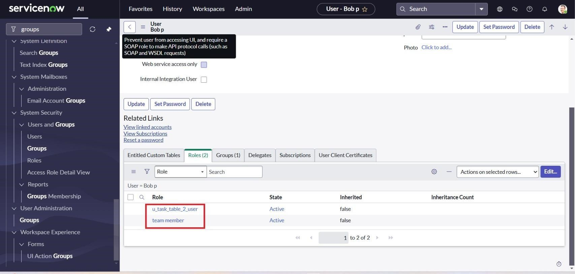

# Figure 10

**Milestone 7: Application Access**

**Activity 1: Assign table access to application**

1. Each table automatically generates an application and module.
2. Search for the 'Project Table' application and edit module roles.
3. Grant access to the 'Project Member' role.
4. Repeat for 'Task Table 2', assigning both Project Member and Team Member roles.

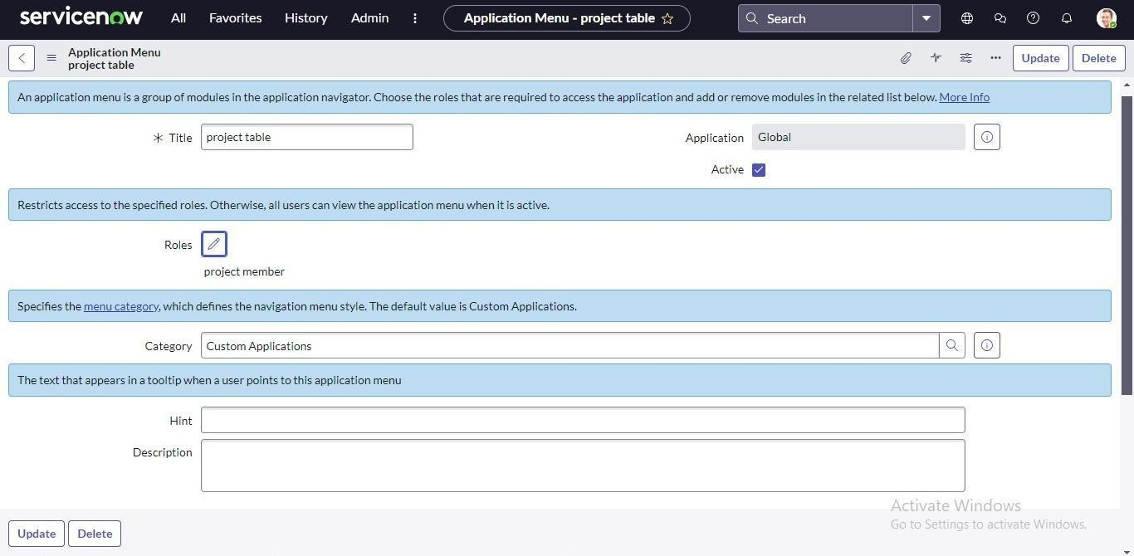

# Figure 11

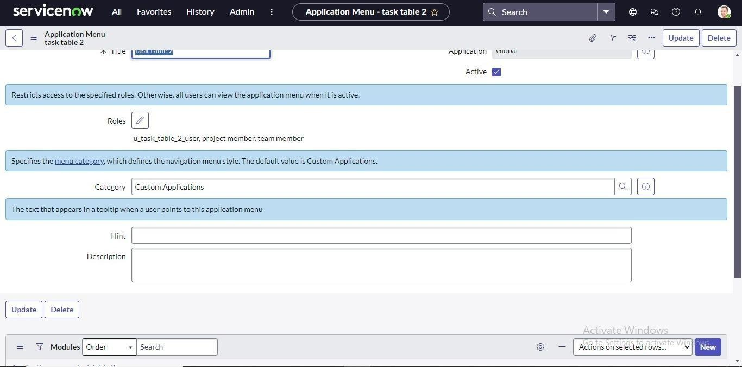

# Figure 12

**Milestone 8: Access Control Lists**

**Activity: Create ACL**

1. Open ServiceNow.
2. Navigate to All → ACL.
3. Under System Security, select Access Control (ACL).
4. Click on Elevate Role.
5. Click New to create a new ACL.
6. Enter the required details for the ACL configuration.
7. Scroll down to the Requires Role section.
8. Double-click to insert a new row.
9. Assign the Task Table and the Team Member role.
10. Click Submit to save.
11. Repeat the process to create four additional ACLs for the specified fields.
12. Go to the profile icon in the top-right corner and click Impersonate User.
13. Select Bob as the impersonated user.
14. From the application menu, navigate to All → Task Table 2.
15. Verify that the Comment and Status fields are accessible for editing

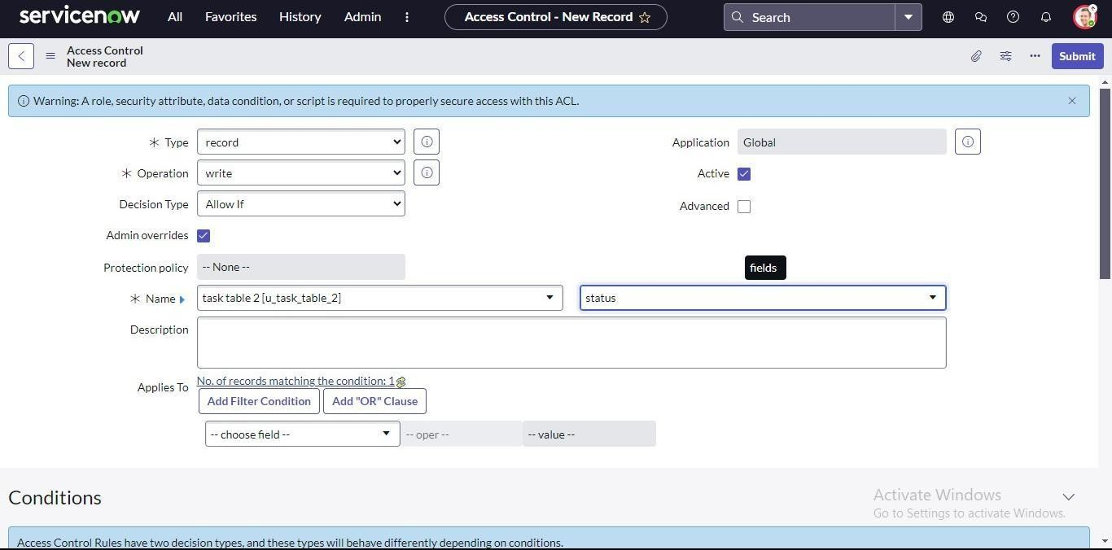

# Figure 13

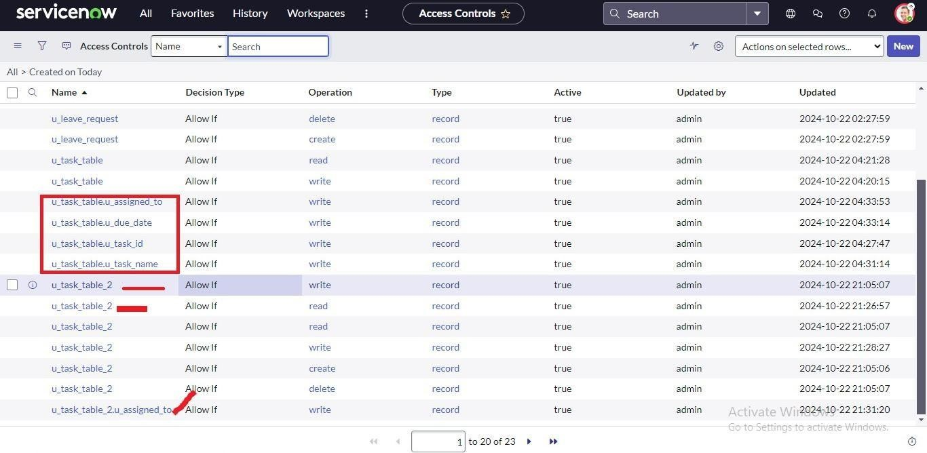

# Figure 14

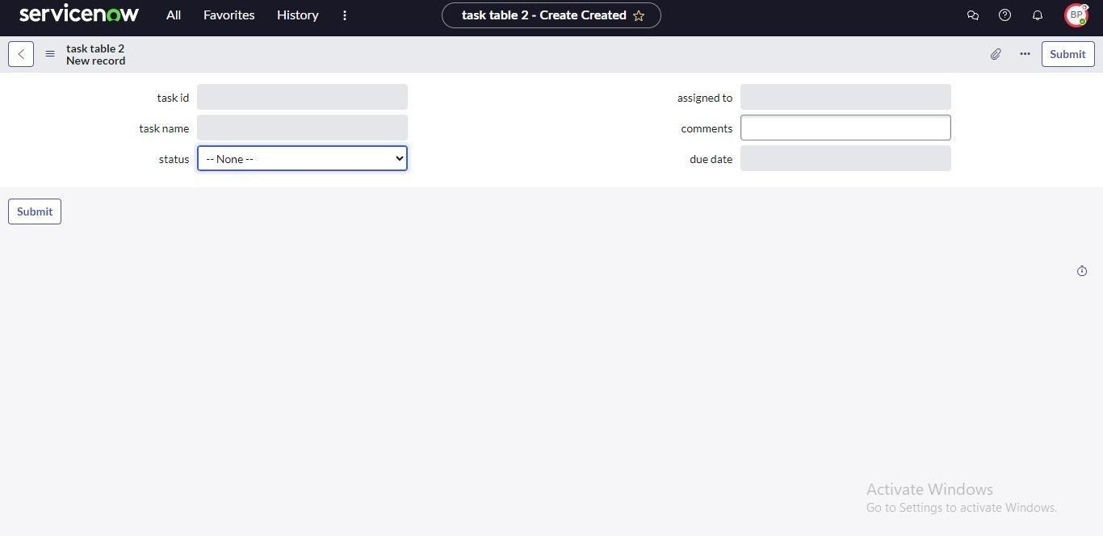

# Figure 15

**Milestone 9: Flow**

**Activity 1: Create a Flow to Assign Operations ticket to group**

1. Open ServiceNow.
2. Go to All → Flow Designer under Process Automation.
3. Click New, then select Flow.
4. In Flow Properties, set the Flow Name as “Task Table”.
5. Choose Global as the application.
6. Click Build Flow to proceed.

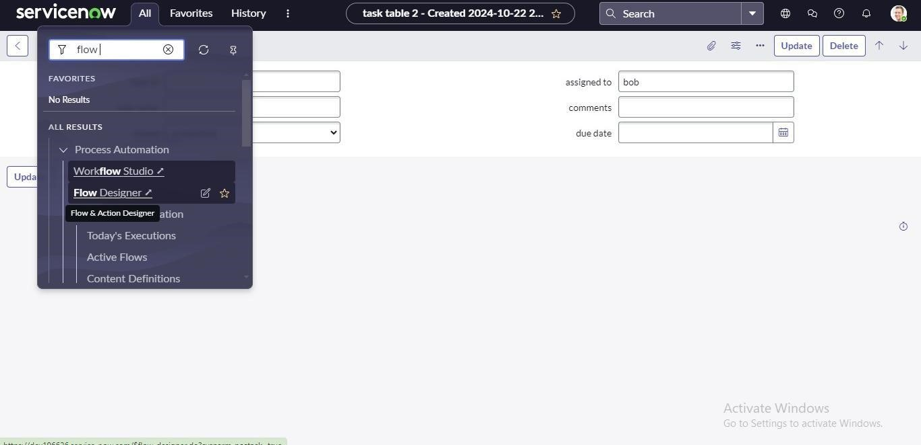

# Figure 16

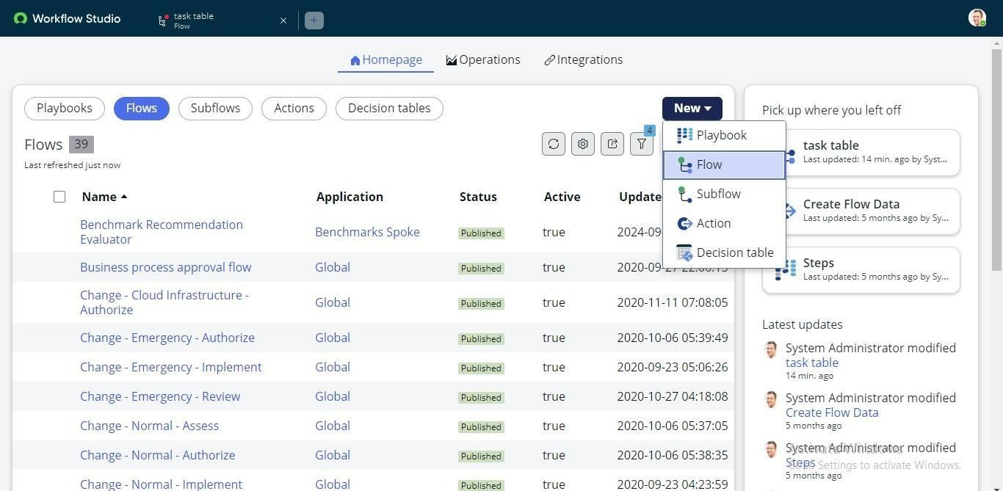

# Figure 17

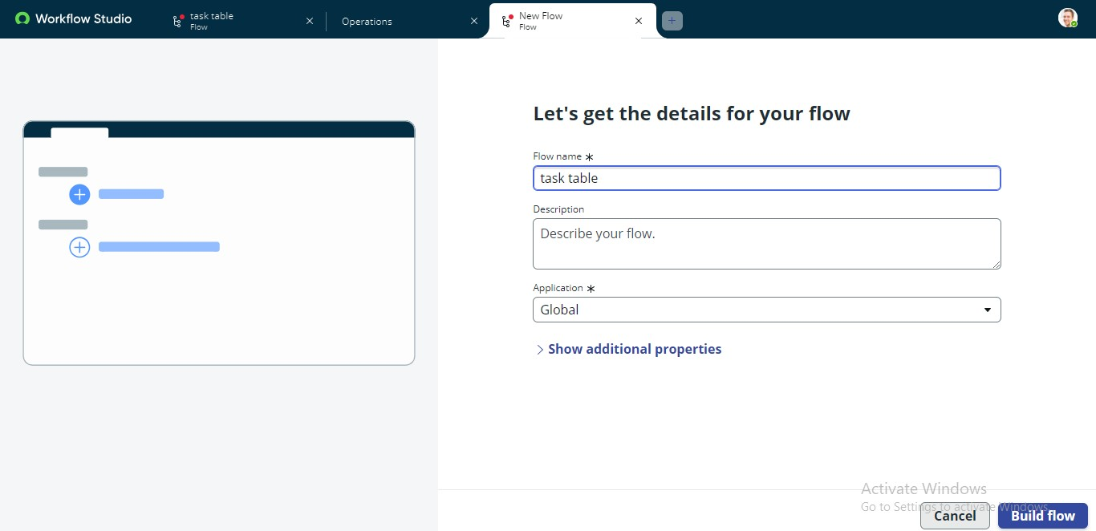

# Figure 18

**Next Step:**

1. Click Add a Trigger.
2. Search and select Create Record.
3. Set the table name to Task Table.
4. Define conditions:

Status → In Progress

Comments → Feedback

Assigned To → Bob

1. Click Done to save.

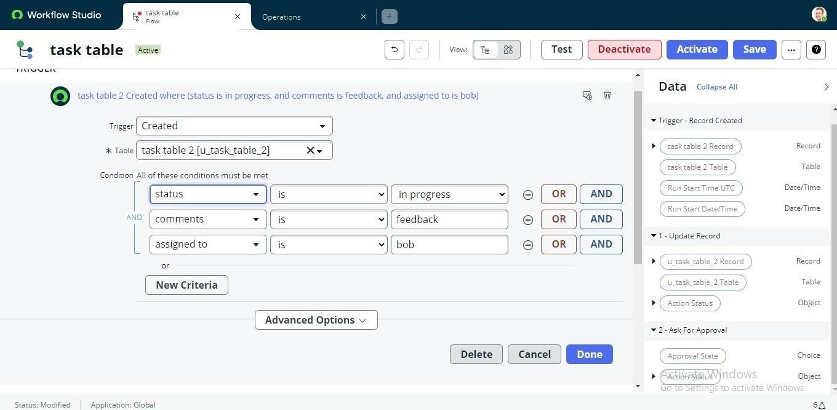

# Figure 19

**Next Step:**

1. Click Add an Action.
2. Search and select Update Records.
3. In the Record field, drag the required fields from the right-side data panel.
4. The table will auto-assign.
5. Set the field Status to the value Completed.
6. Click Done to save.

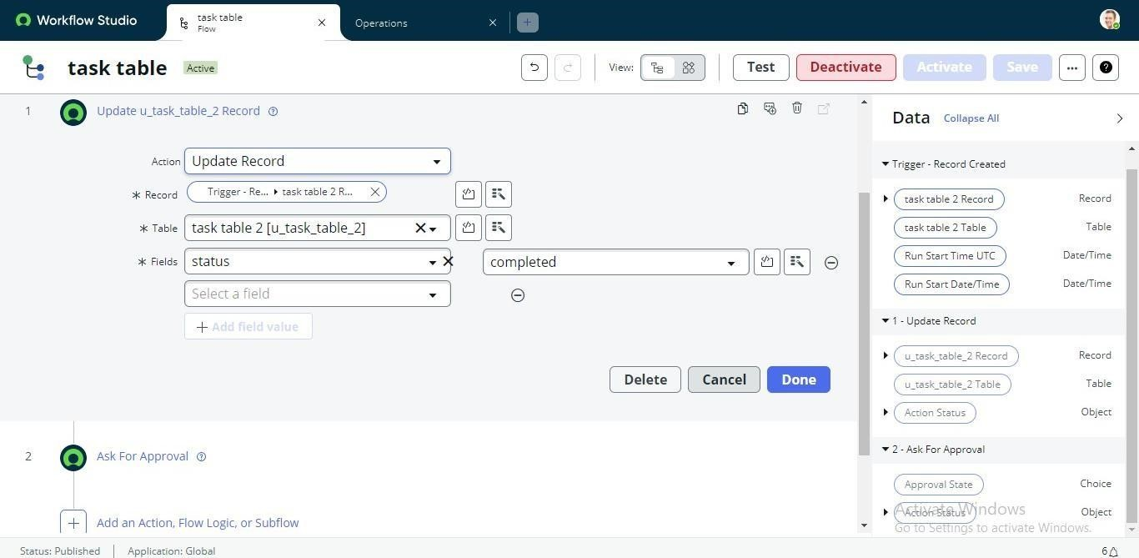

# Figure 20

**Next Step:**

1. Under Actions, click Add an Action.
2. Search and select Ask for Approval.
3. In the Record field, drag the required fields from the right-side data panel.
4. The table will auto-assign.
5. Set the approval field to Status.
6. Assign Alice P as the approver.
7. Click Done to save.

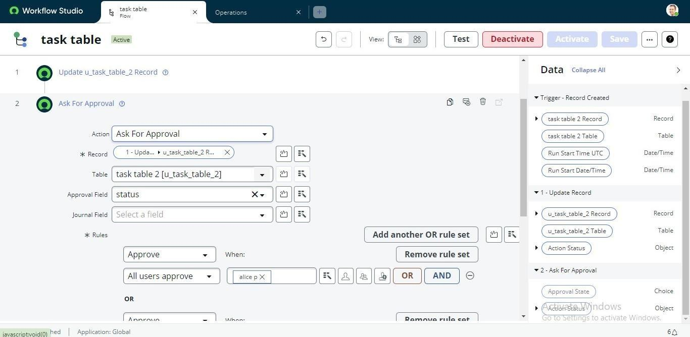

# Figure 21

1. In the Application Navigator, search for Task Table.
2. Verify that the Status field is updated to Completed.

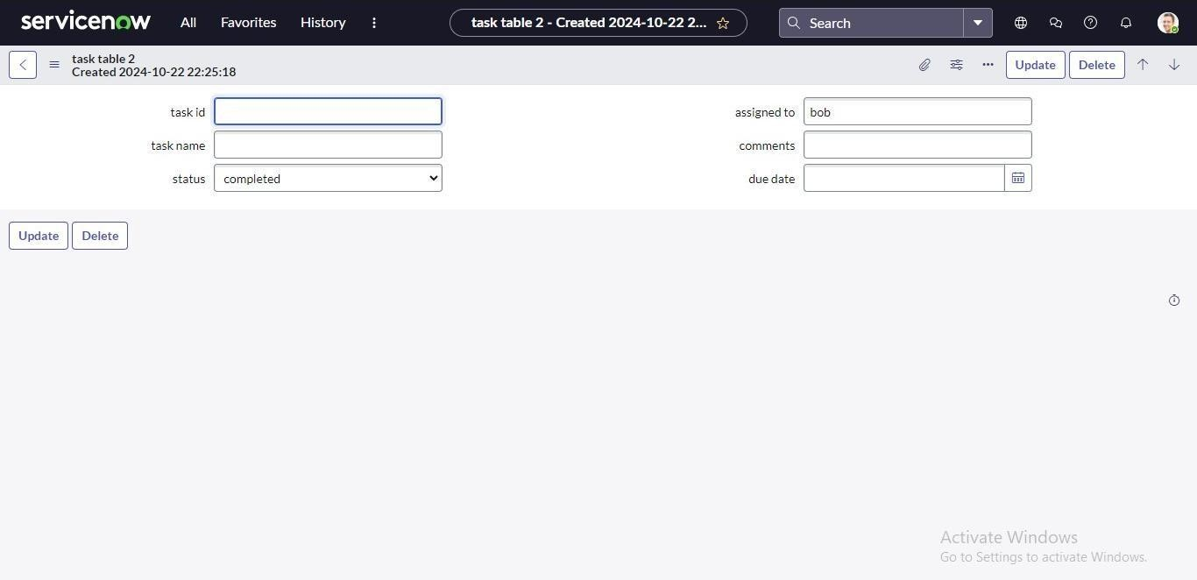

# Figure 22

1. Open the Application Navigator and search for My Approvals.
2. Click on My Approvals under Service Desk.
3. Alice P will receive an approval request. Right-click on the request and select Approve.

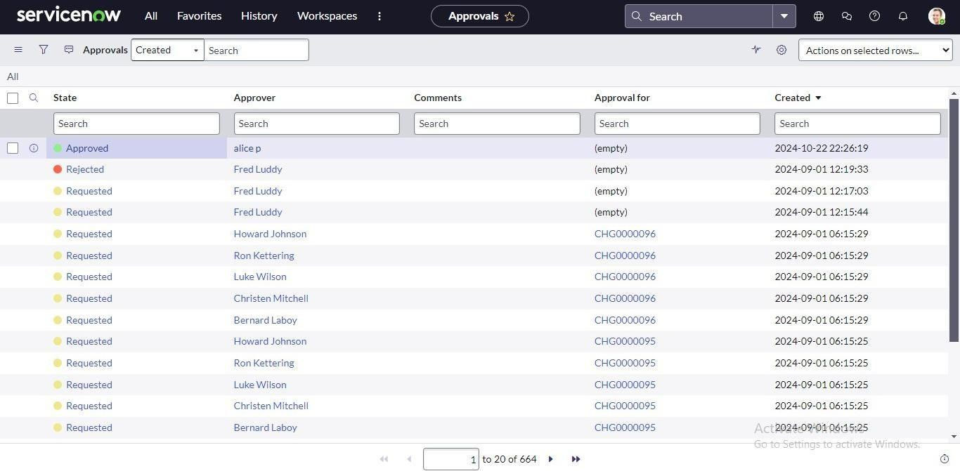

# Figure 23

**Conclusion:**

This scenario demonstrates a well-structured approach to project management by clearly defining the roles of Alice and Bob within an organized workflow. With Alice providing direction and Bob executing assigned tasks, the team collaborates effectively to achieve project goals. The use of tables helps in systematically organizing key information, making it easier to monitor projects, tasks, and progress updates. Overall, this system strengthens accountability, improves communication, and supports the successful completion of projects.